**Read the article and answer the questions.**

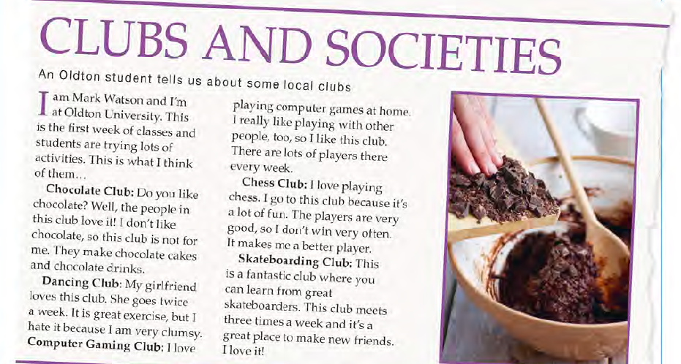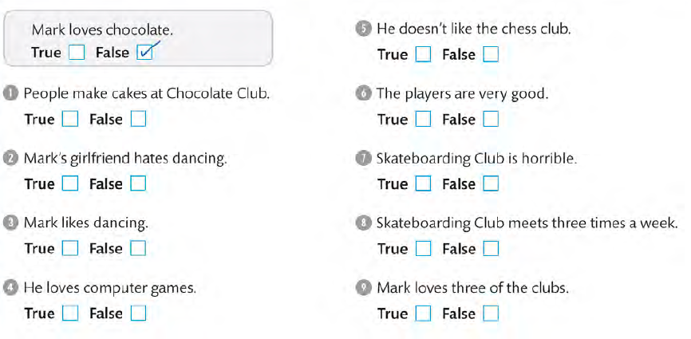

**ANSWER KEY**

1. T
2. F
3. F
4. T
5. F
6. T
7. F
8. T
9. T